**GIG Feedback 23042015**

1. Homepage/General
   1. Spelling error. The word "Enquiries" is spelt wrongly. It should be E-N-Q-U-I-R-I-E-S, with an extra "i" before the "r"



* 1. The address listed is not correct please change to " Blk 2023 Bukit Batok Industrial Park A Street 23, #04-84, Singapore 659528"



1. Contact Page
   1. The address listed here is not correct as well. Please change to " Blk 2023 Bukit Batok Industrial Park A Street 23, #04-84, Singapore 659528"

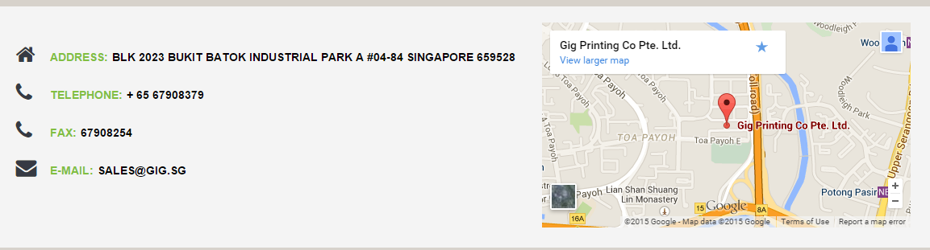

* 1. The google map location is also not correct. Use the embedding codes below instead.

<iframe src="https://www.google.com/maps/embed?pb=!1m18!1m12!1m3!1d63819.53347773014!2d103.75221699999999!3d1.3439061283403484!2m3!1f0!2f0!3f0!3m2!1i1024!2i768!4f13.1!3m3!1m2!1s0x31da1014d3aa72bd%3A0x8c48080bc820126b!2sGig+Printing+Co+Pte+Ltd!5e0!3m2!1sen!2ssg!4v1429506088617" width="487" height="260" frameborder="0" style="border:0"></iframe>

1. Sale for images
   1. Backend
      1. The Client are selling stock images as mention, thus there is a need for them to upload high res image. Please resolve the problem below where they cannot upload the images that are too big.

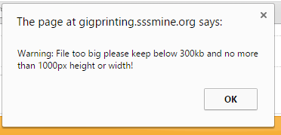

* + 1. When Client enter a name that is too long, then name will run out of alignment. Please specify the number of characters allow or solve the system to allow longer words



1. Fundamental issue with system
   1. By right Open Cart allows the system to create subfolder under a parent folder. I tried but it is not appearing in the frontend.

As seen below, all the other categories is supposed to be a 2nd level categories to the parent category "Image for Sale" It will be weird for the main folder to appear below all the folders.

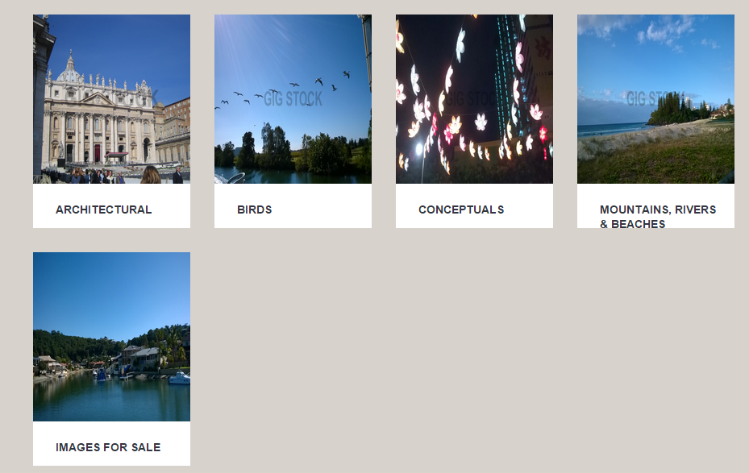

the below image is to show you that we tried to create 2nd level categories using open cart system but not successful

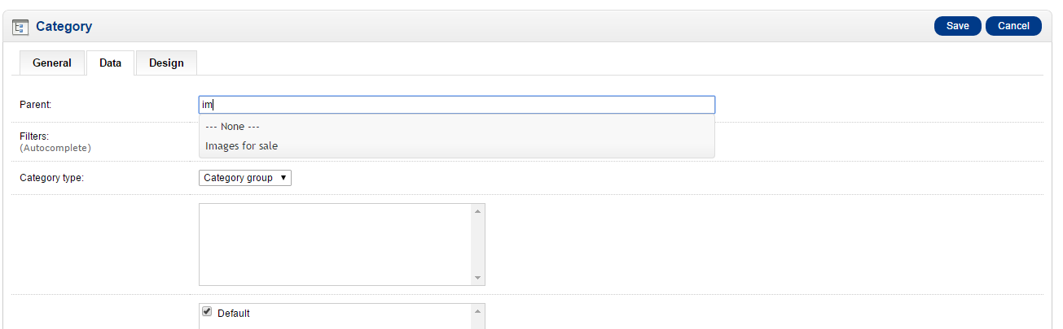

1. Other Points mentioned earlier on
   1. Auto watermark of Product Images.

As mentioned earlier, Client wants to have watermark on images that he upload to sell only. After user made payment, then they will be allow to download images without the watermark. So please start implementing this change

* 1. Downloadable files

As mentioned, please allow the images to be downloadable without watermark after user paid for it.

* 1. Paypal Payment plugin

As mentioned previously, it is essential for a e-commerce site to be integrated with payment gateway. In this case, client wants to use paypal. As observe by our team, it seems that under the backend system- extensions-payment, you can install the paypal plugins easily. Please advise regarding this matter.

